**To:** Recruitment team, Westpac

**Bug report for**

**Buggy Cars Rating web application**

**From:** Sylvain Pissard-Maillet

Contents

Critical bugs 3

Bug #1: Not enough validations on the registration details. 3

Bug #2: Users cannot reset their password. 7

Bug #3: Navigating to the Lancia Stratos car model put the application in a bad state. 9

Other found issues 12

Bug #4: Users cannot navigate back to the main menu easily. 12

Bug #5: The application does not navigate back to the main menu after registering or login. 12

Bug #6: Clicking on a car image brings the user back to the main menu. 12

Bug #7: Order by Vote in the car make section is not working as expected. 12

Bug #8: Order by Model or Rank in the car make section is not working. 12

Bug #9: Order by in the Overall Rating section works only in one way. 12

Bug #10: Spelling mistake. 12

# Critical bugs

## Bug #1: Not enough validations on the registration details.

**Issue details:**

When registering as a new user, the only validations done are:

* The username has a length of at least one character, excluding white spaces
* The first name has a length of one character at least, including white spaces
* The last name has a length of one character at least, including white spaces
* The password has a length of six characters minimum, white spaces not accepted
* The password contains an upper case and a lower case letter
* The password contains a number
* The password contains a symbol character
* The password and Confirmation password matches

The above-mentioned validations are only strict with the password and allows the user to set the username, first name and last name to nearly anything. The user could set its username to a number, a letter, or even a symbol/special character and would be able to register without issue. The user can also register by providing empty first name and last name by simply adding a space in the text field.

This limited validation on the other fields could create long-term issues for the users as well as for the administrators. One the issue would be the identification of the user. When voting, the user can write an offensive comment and the administrators could have trouble in identifying the user and suspend the account, if they wished to do so. Many other issues could arise; depending of direction the web application evolves.

**Reproduction steps:**

Step 1: Navigate to the Buggy Cars Rating website using the following URL: <https://buggy.justtestit.org/> Expected result: the home page opens as below.

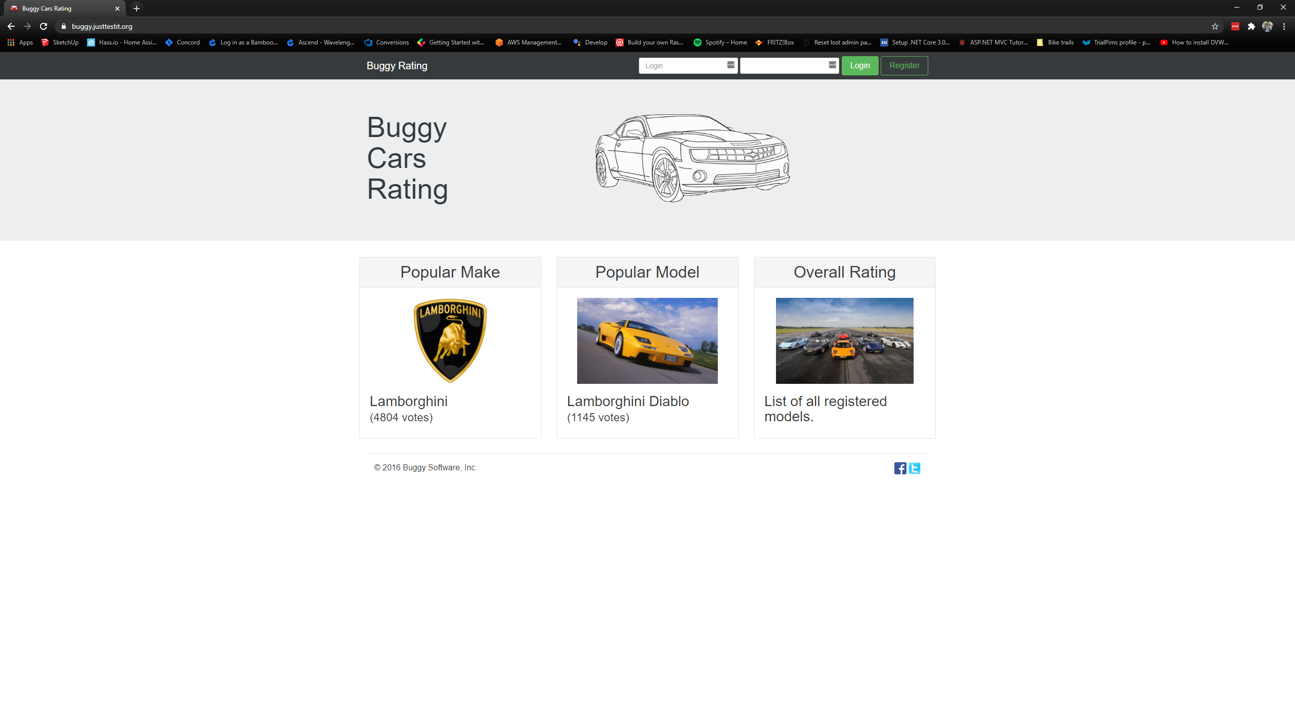

Step 2: Click on the Register button. Expected result: the registration form displays, as below.

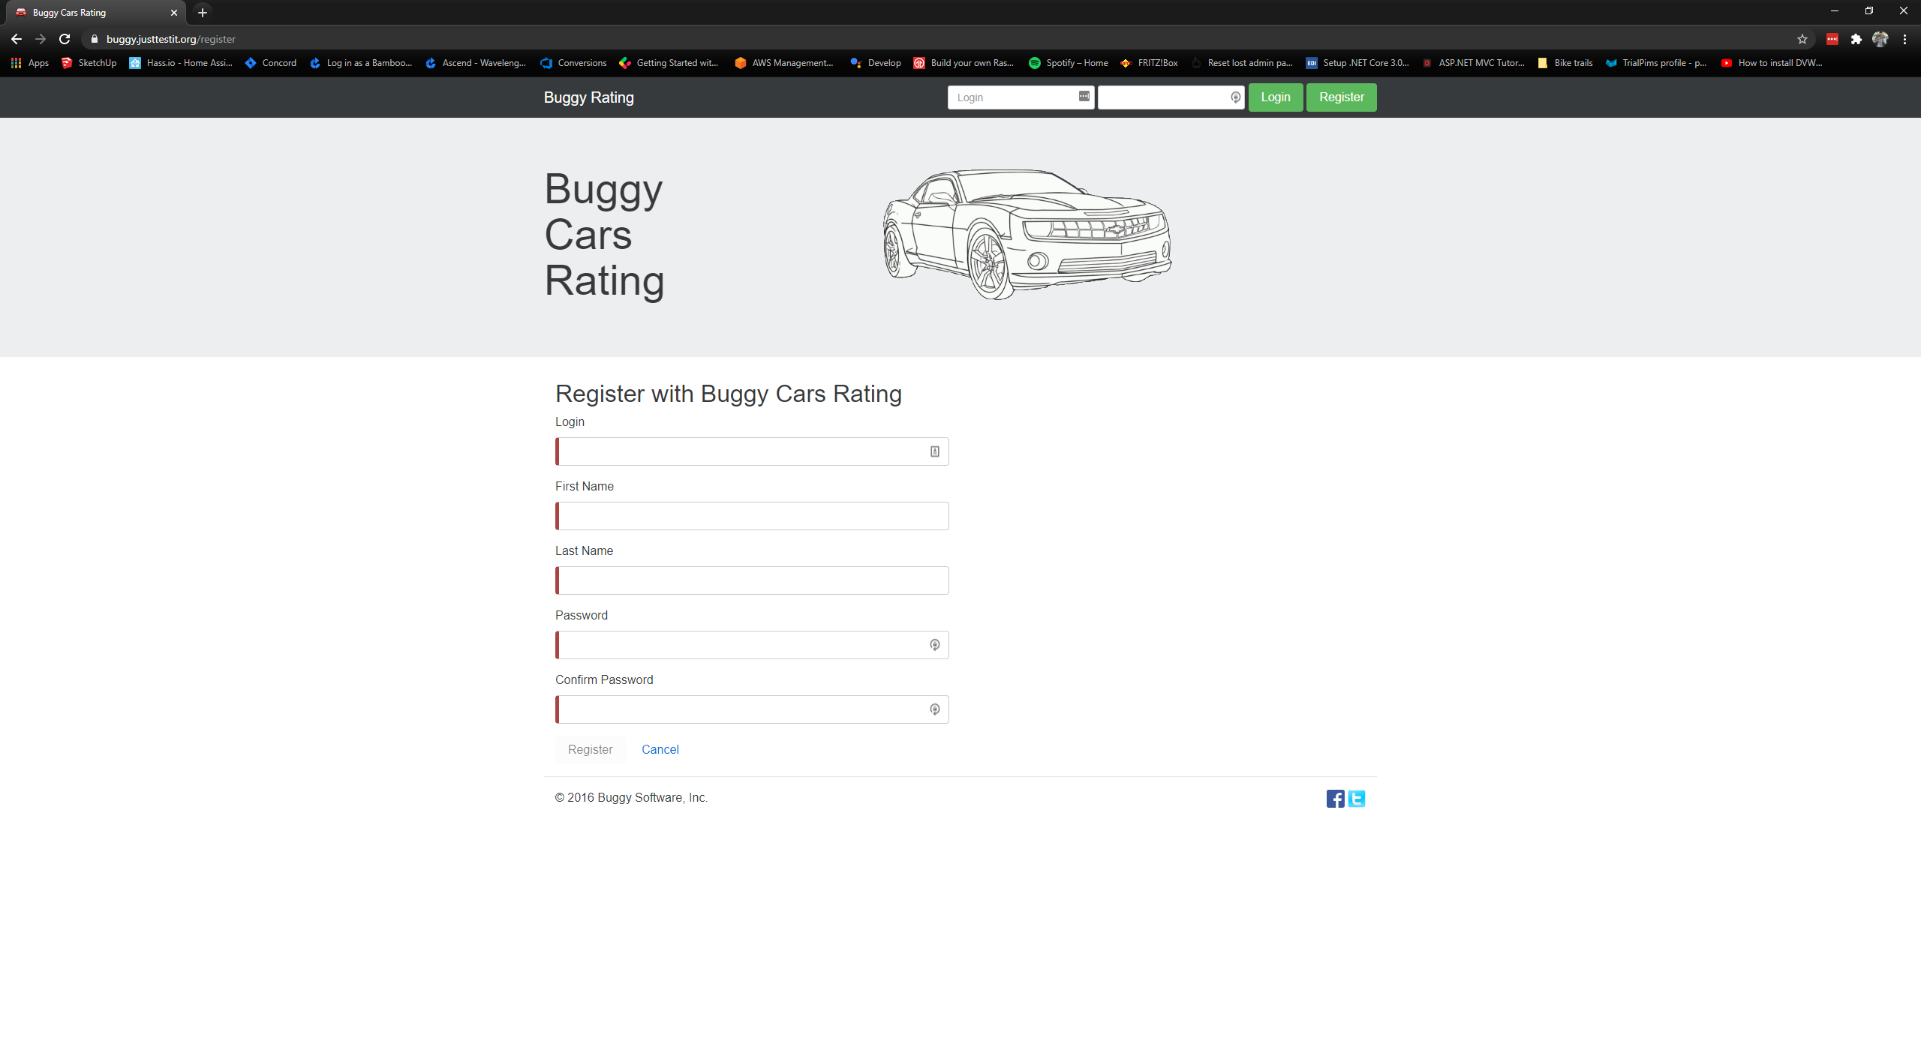

Step 3: Fill the Login filed with the number 1. Fill the First name with a white space and the last name with !@#$%^&*()_+}{. Fill the password and confirm password fields to pass the validation. The form should look something like below.

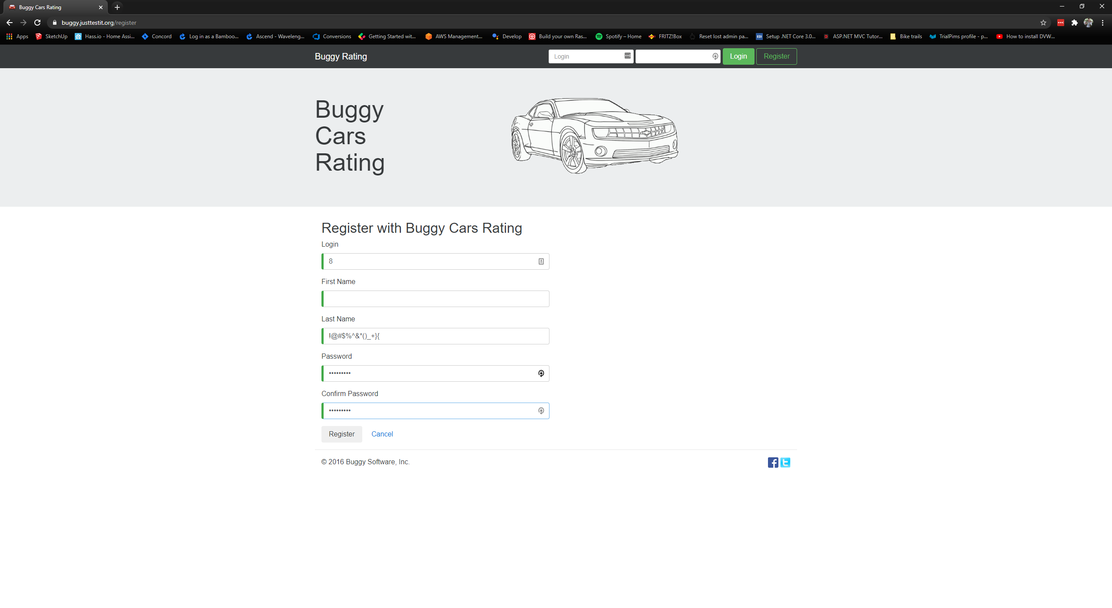

Step 4: Click the Register button. The registration should be successful, as below. Note: If an error appear, saying the login already exists, change the login to something else and try again.

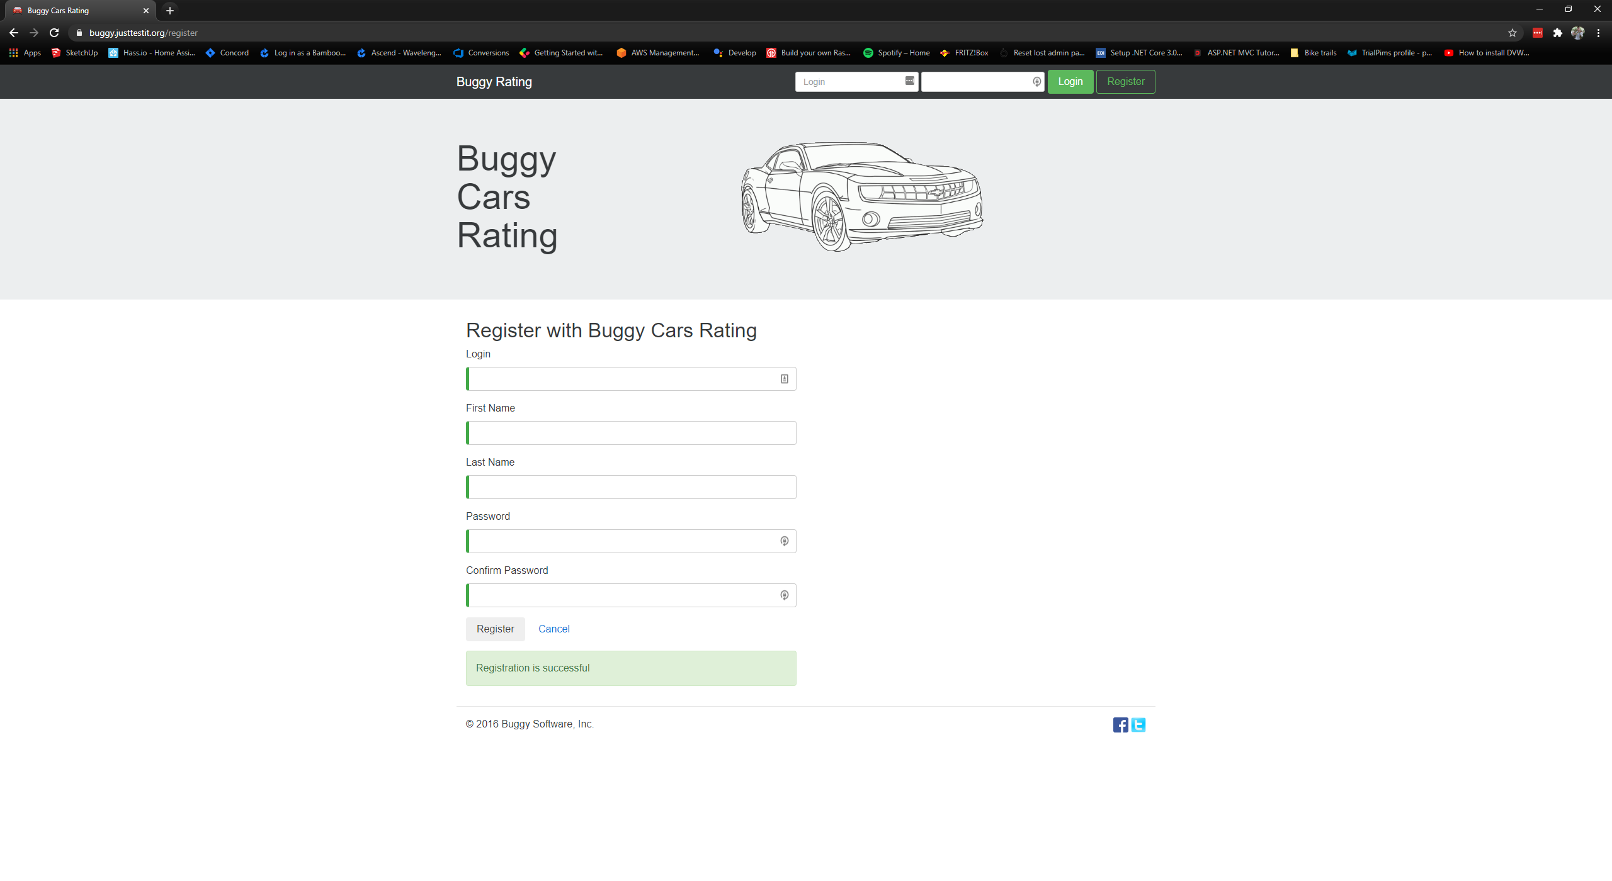

**Proposed solution:**

Increase the validation on the login, first name and last name fields. Add a length validation to the login field. Add a length and a character validation to the first and last name fields. The user should not be able to add a name less than four characters, for example. The user should not be able to add symbol/special characters to the first and last name such as !@#$%^&*()_+={}[]:”;<>?,./\|~` However the user should be able to use accepted characters such as – ‘ The application should trim leading and trailing white spaces.

**Acceptance criteria:**

* The login field has a validation on the length of the string given.
* The first name and last name fields have validation for symbol/special characters.
* The first and last name fields have a validation on the length of the string given.
* The leading and trailing white spaces are trimmed.
* The application cannot save the registration id any of the validation are not respected.

## Bug #2: Users cannot reset their password.

**Issue details:**

The users are relying on the possibility to login to change their personal details as well as being able to vote. Users can forget their passwords, it happens. However, users cannot reset their password if they forgot it. The only option for them would be to register again to be able to vote and change personal data.

It is a frustration point for users as they should be able to reset their password anytime without having to re-register every time they forget their password.

**Reproduction steps:**

Step 1: Navigate to the Buggy Cars Rating website using the following URL: <https://buggy.justtestit.org/> Expected result: the home page opens as below.



Step 2: Try to login using the login from the previous bug but using a wrong password. Try this multiple times. Expected result: The user cannot login and a message bubble appear, as below.

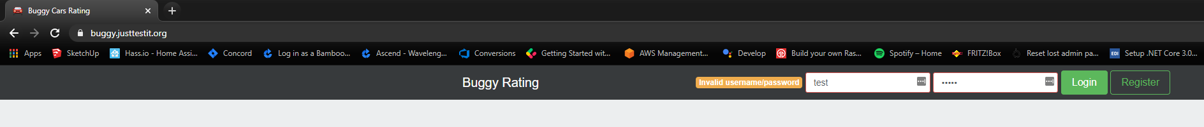

Step 3: No option to rest the password.

**Proposed solution:**

The application should offer the possibility for the user to reset their password. Adding a button or hyperlink next to the Register button would be enough. Clicking this button/hyperlink would result in a new modal window or navigate to a page that allows the user to rest their password after completing a user verification. As it is common practice.

**Acceptance criteria:**

* The application has a button or hyperlink to direct the user to the password rest page.
* The password is resettable via the page.
* The password reset action has user verification to confirm user and avoid potential hacking attempt.

## Bug #3: Navigating to the Lancia Stratos car model put the application in a bad state.

**Issue details:**

Users can navigate to every car model, which allows them to vote for the model, add a comment and view details about the model. However, when a user navigate to the Stratos model from the Lancia brand, the application gets in a bad state and becomes unusable until the user refreshes the page.

**Reproduction steps:**

Step 1: Navigate to the Buggy Cars Rating website using the following URL: <https://buggy.justtestit.org/> Expected result: the home page opens as below.



Step 2: Navigate to the Overall Ranking section of the application. Expected result: a table that lists the cars model is open, as below.

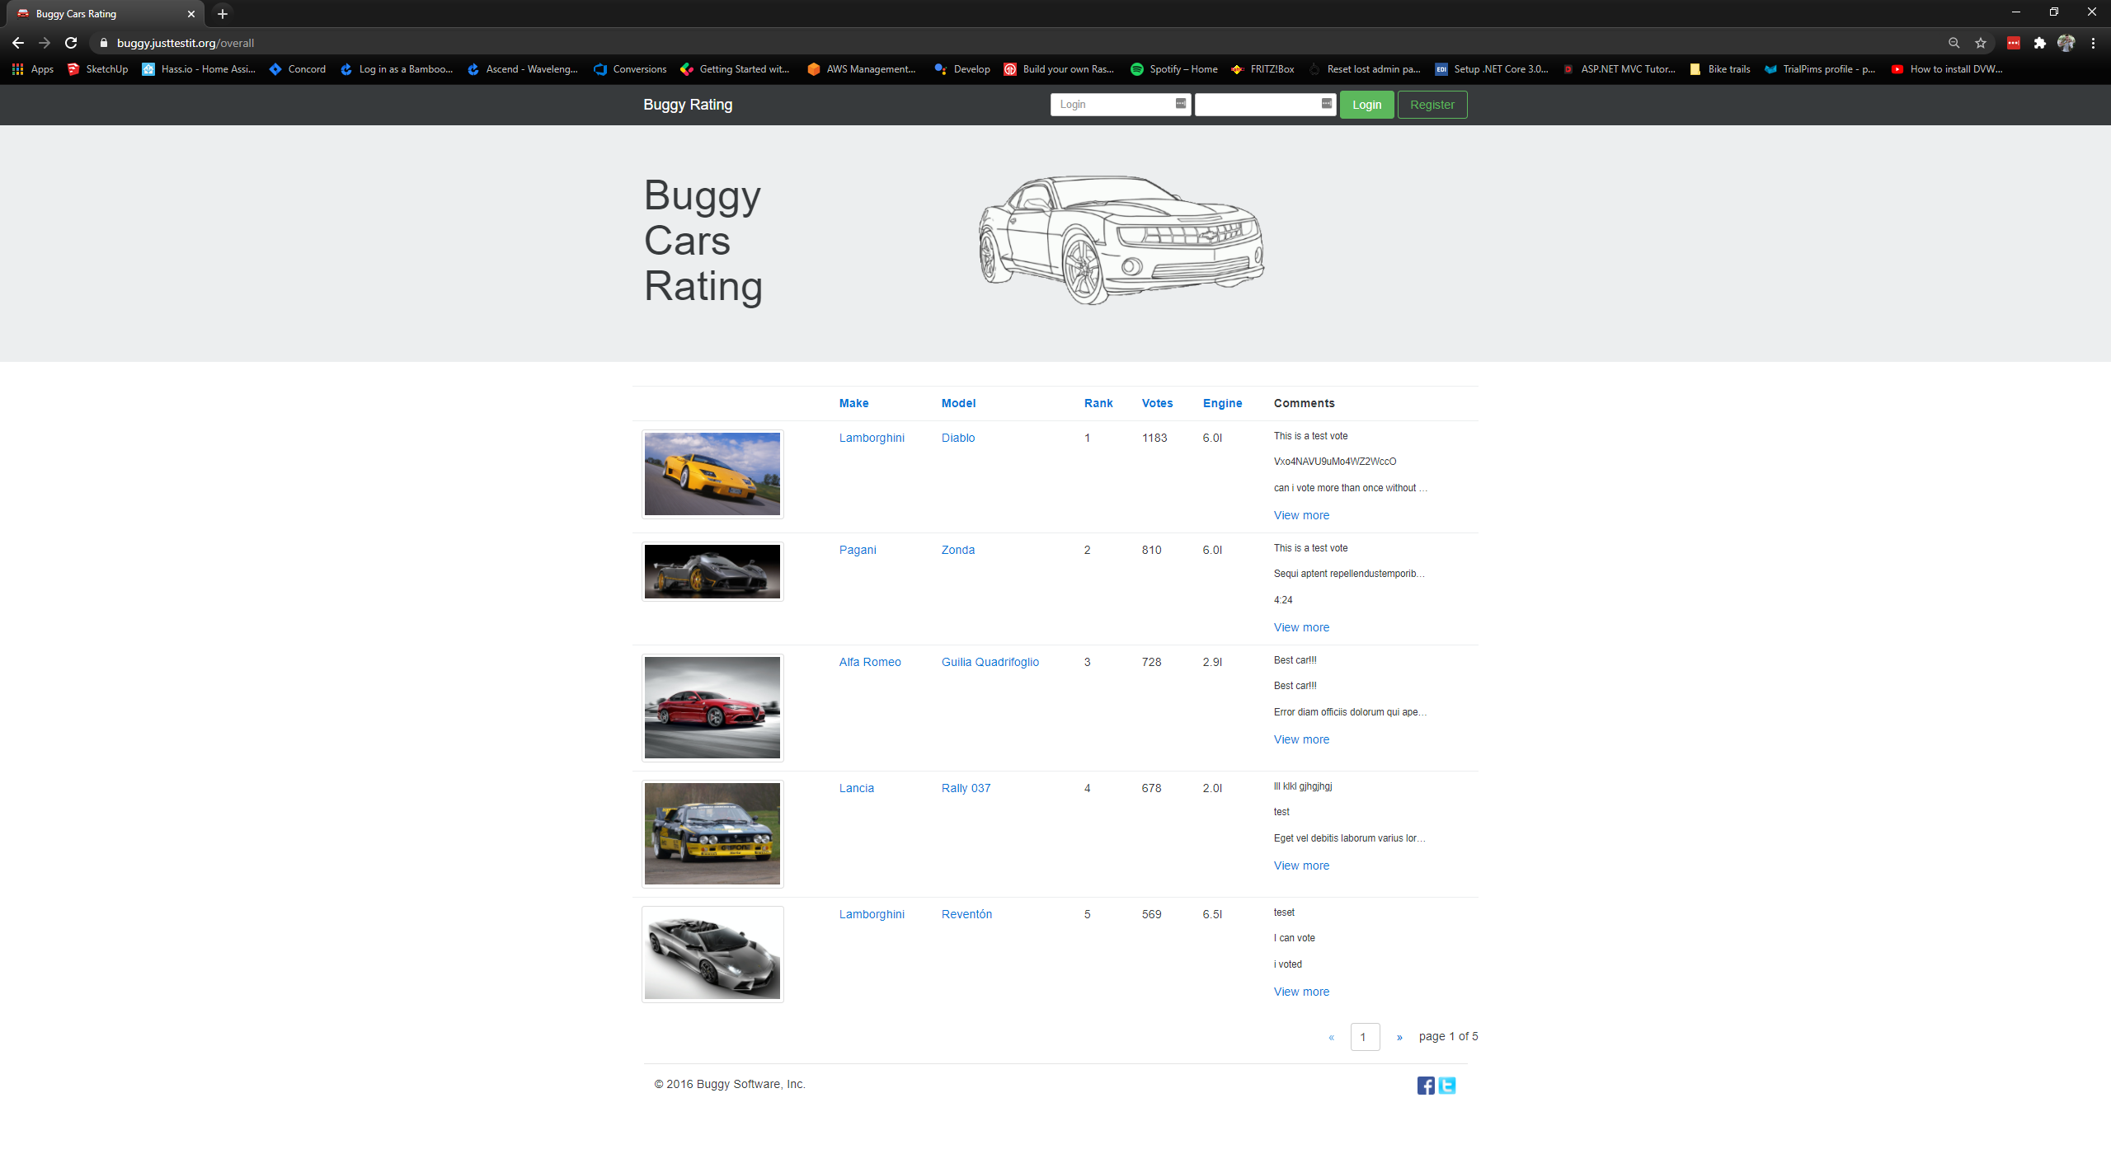

Step 3: Select the Lancia brand to navigate to the Lancia car mmodels. Expected result: the Lancia page open with the list of models, as below.

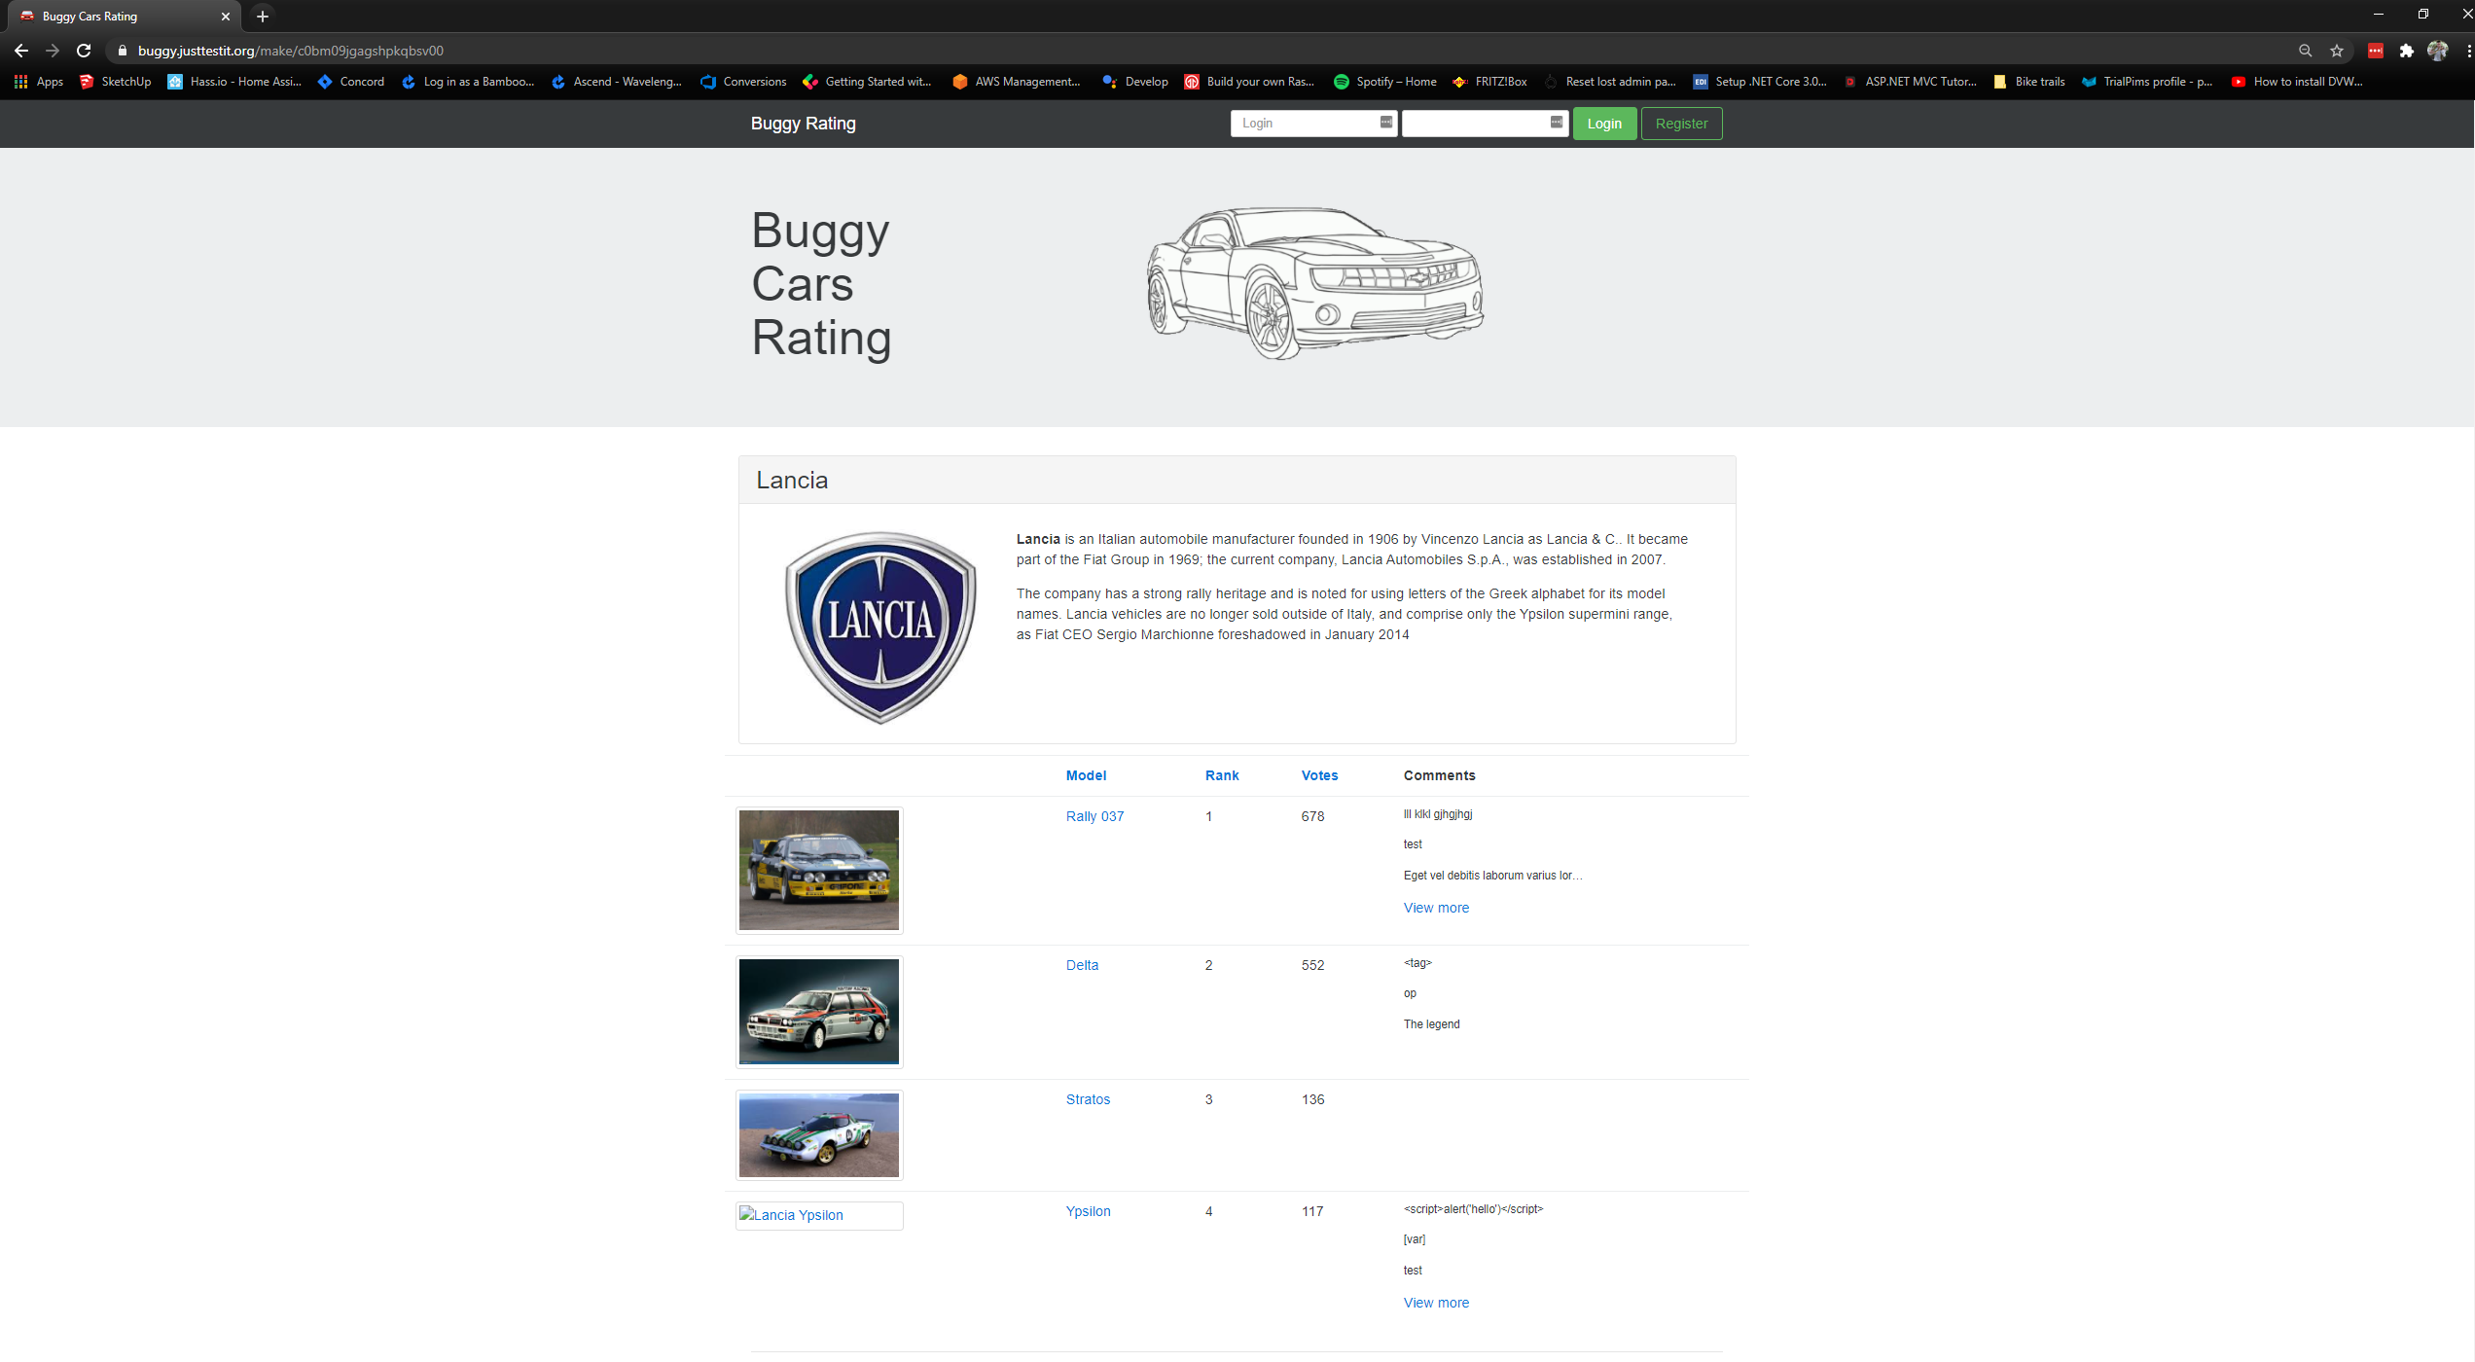

Step 4: Select the Stratos car model. Expected result: the car model page is displayed but errors are visible such as no data or image of the car displayed, as below.

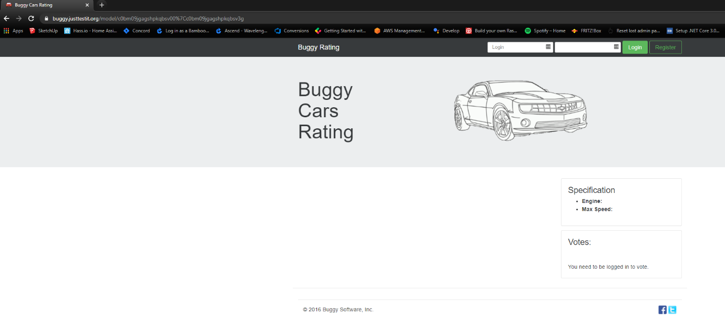

Step 5: Try to navigate back to the home menu. Expected result: the page is cleared but the user is not redirected to the home page as expected, as below.

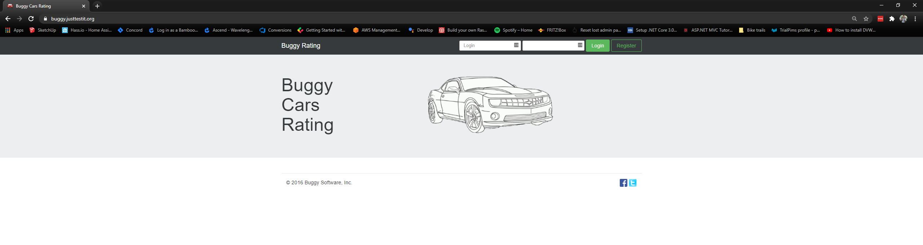

Step 6: Refresh the page. Expected result: the home page is visible again.

A video is available here: “BuggyCarsRating/Documents/Bug_#3_Video.gif” for better illustration of the issue.

**Proposed solution:**

Every car model should be visible. Implementation of a verification step to ensure the creation of a car model is not saved with missing information that may break the application. In the event of an issue like this happening, the application should handle it gracefully by displaying and error message and allowing the user to navigate back to the main menu.

**Acceptance criteria:**

* The application handle error in such a way that the user can still use the application.
* Car model creation have a validation step for any mandatory information needed.

# Other found issues

## Bug #4: Users cannot navigate back to the main menu easily.

Users cannot navigate back from the make section of the application by clicking the Buggy Rating icon in the top left of the screen.  Instead, they would need to navigate to a car model and click on the image.

## Bug #5: The application does not navigate back to the main menu after registering or login.

Users can register or login if already registered. However, the users must manually navigate back to the main menu after the registration or login. The application should bring the user back to the main menu automatically after those actions.

## Bug #6: Clicking on a car image brings the user back to the main menu.

When users are looking at a car model details, an image of the model is available. However, when clicking the image, the user is directed back to the main menu instead of expanding the image, as the user would expect due to this behaviour being common practice.

## Bug #7: Order by Vote in the car make section is not working as expected.

When clicking on the Vote column title, the user would expect the order to change from most vote to least vote or vice versa. However, the column appear to be sorted at random, just moving records without obvious logic.

## Bug #8: Order by Model or Rank in the car make section is not working.

Seeing the Model and Rank column titles, users would expect the possibility to order using those columns. However, nothing is happening when clicking on those column titles.

## Bug #9: Order by in the Overall Rating section works only in one way.

When clicking on the column titles in this section the user can order the items displayed by a preferred column. However, the ordering works only in one way. Therefore, the user can only sort in alphabetical order for the Make and Model, the rank appears to sort by number family, 1, 10, 11… instead of 1, 2, 3… as expected. Votes orders only from largest to smallest and Engine orders only from smallest to largest.

## Bug #10: Spelling mistake.

When the user save changes in the profile section, a message appears. “The profile has been save successful”. It should say “successfully”.